ERD in Visual Paradigm:

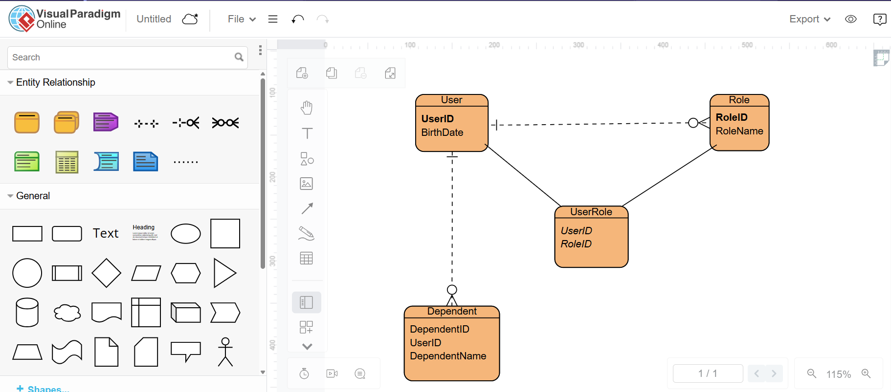

NoSQL Data Structure:

{

"UserID": "U123",

"BirthDate": "1990-01-01",

"Roles": [

{"RoleID": "R1", "RoleName": "Admin"},

{"RoleID": "R2", "RoleName": "User"}

],

"Dependents": [

{"DependentID": "D1", "DependentName": "John Doe"},

{"DependentID": "D2", "DependentName": "Jane Doe"}

]

}